VERIFICATION

I, the undersigned, state: I am the ,
(“Agent of”, “President of”, “A Partner of”, “Owner of”, etc.)
the owner identified in the foregoing ___________________________; I have read said document and know the contents thereof, and I certify that the same is true of my own knowledge.

I declare under penalty of perjury under the laws of the State of California that the foregoing is true and correct.
Dated: | By:
 | Name (print)

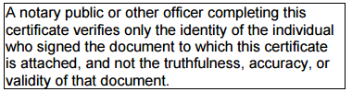
State of California
County of ______________________} ss.
On _____________________________, _______ (date), before me, ________________________________, notary public (name and title of officer) personally appeared _______________________________, who proved to me on the basis of satisfactory evidence to be the person(s) whose name(s) is/are subscribed to the within instrument and acknowledged to me that he/she/they executed the same in his/her/their authorized capacity(ies), and that by his/her/their signature(s) on the instrument the person(s), or the entity upon behalf of which the person(s) acted, executed the instrument. I certify under PENALTY OF PERJURY under the laws of the State of California that the foregoing paragraph is true and correct.

(seal)
Witness my hand and official seal. _________________________________
Signature of Notary

